Jonas Ejby Madvig  
jona08n9

# Hacked Hogwarts Project

[Githubrepo](https://github.com/jona08n9/Frontend/tree/main/hogwarts/cleaning-hogwarts-data) -   
<https://github.com/jona08n9/Frontend/tree/main/hogwarts/cleaning-hogwarts-data>

[kortlink.dk/2k9q5](https://kortlink.dk/2k9q5)

[Own webpage](http://madvigux.dk/frontend/hogwarts_project/) -   
<http://madvigux.dk/frontend/hogwarts_project/>

[kortlink.dk/2k9q4](https://kortlink.dk/2k9q4)

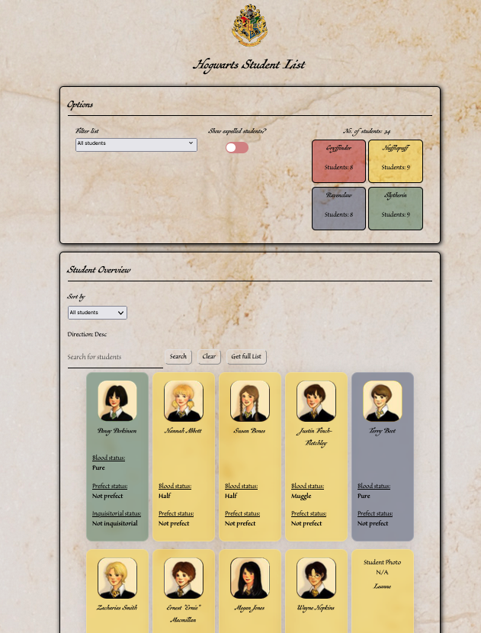

# Links

[PDF til wireframe](http://madvigux.dk/frontend/hogwarts_project/Documents/WIREFRAME_HOGWARTS.pdf) -

<http://madvigux.dk/frontend/hogwarts_project/Documents/WIREFRAME_HOGWARTS.pdf>

[kortlink.dk/2k9pz](https://kortlink.dk/2k9pz)

[Activity diagram as SVG](http://madvigux.dk/frontend/hogwarts_project/Documents/hogwarts_activitydiagram.svg) –

<http://madvigux.dk/frontend/hogwarts_project/Documents/hogwarts_activitydiagram.svg>

[kortlink.dk/2k9q2](https://kortlink.dk/2k9q2)